**Course6-Sing a song**

****Learning goals:****

In this lesson, you can use the micro:bit robot to play music, the robot sings a happy birthday song, and the dot matrix displays a buzzer pattern.

**Code：**

from microbit import *

import music

boat = Image("00090:90990:99990:90990:00090")

display.show(boat)

music.play(music.BIRTHDAY)

**Below is a complete list of melody:**

• music.DADADADUM  
• music.ENTERTAINER

• music.PRELUDE  
• music.ODE  
• music.NYAN  
• music.RINGTONE  
• music.FUNK  
• music.BLUES  
• music.BIRTHDAY  
• music.WEDDING  
• music.FUNERAL  
• music.PUNCHLINE  
• music.PYTHON  
• music.BADDY  
• music.CHASE  
• music.BA_DING  
• music.WAWAWAWAA  
• music.JUMP_UP  
• music.JUMP_DOWN  
• music.POWER_UP  
• music.POWER_DOWN

**Programming and downloading：**

1. You should open the Mu software, and enter the code in the edit window, , as shown in Figure 6-1.

**Note! All English and symbols should be entered in English, and the last line must be a space.**

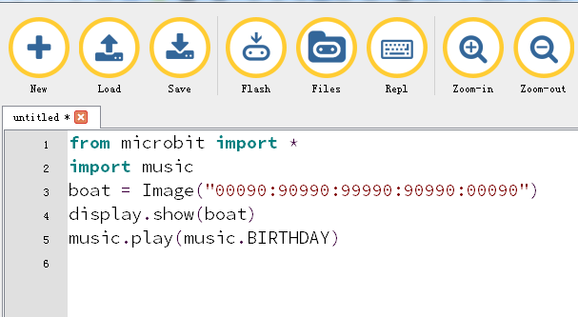

Figure 6-1

2.As shown in Figure 6-2, you need to click the Check button to check if our code has an error. If a line appears with a cursor or an underscore, the program indicating this line is wrong.

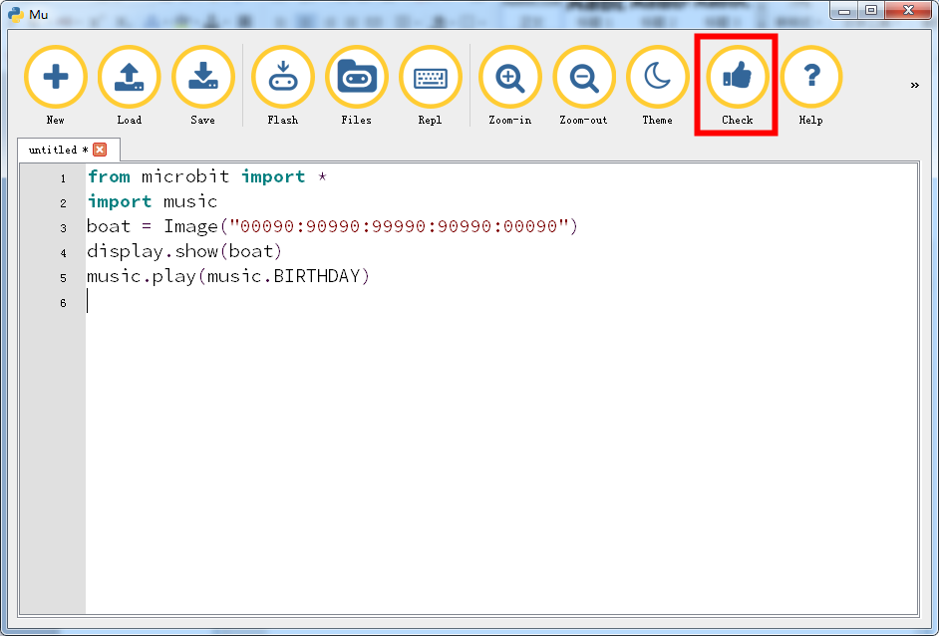

Figure 6-2

3.You need to connect the micro data cable to micro:bit and the computer, then click the Flash button to download the program to micro:bit as shown in Figure 6-3.

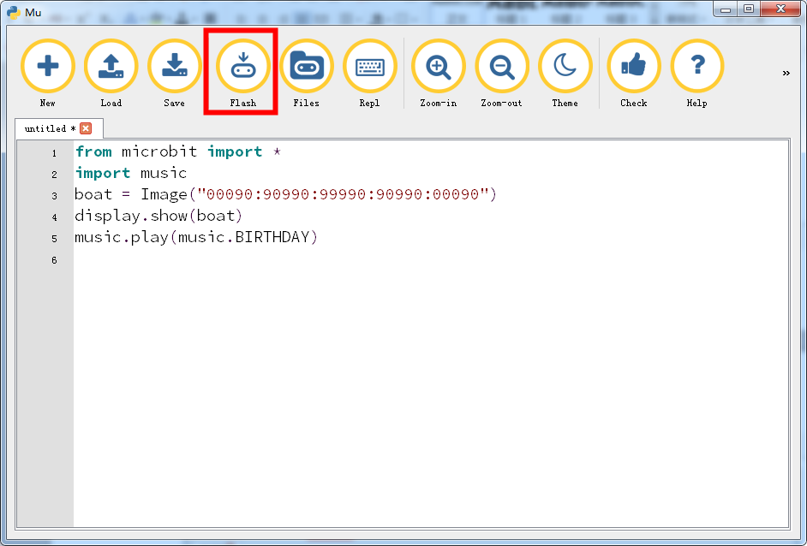

Figure 6-3

4.After downloading the program, you can hear Micro:bit playing Happy Birthday and a buzzer on the micro:bit dot matrix. as shown in Figure 6-4.

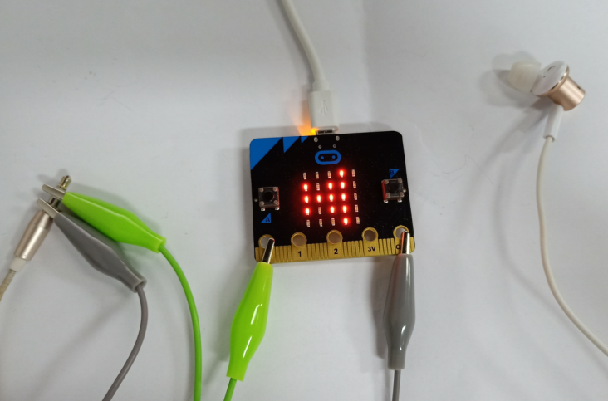

Figure 6-4